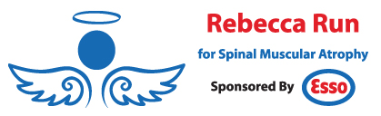

2019 Rebecca Run Honouree Nominee Application Form

Nominations close on Sunday October 14, 2018.

The honouree for 2019 will be announced in October.
If you have any questions, please email us at info@rebeccarun.com.

Nominee Name:
Nominee Date of Birth:
Nominee Date of Death (if applicable):
Type of SMA:
Mother Name:
Contact Number:
Email Address:
Father Name:
Contact Number:
Email Address:
Physical Address:

Tell us why you feel your nominee is the ideal candidate to be the 2019 Rebecca Run for SMA Run Honouree. Share your story with us (in 400 words or less) and if possible, include a photo of your nominee along with your application form.

